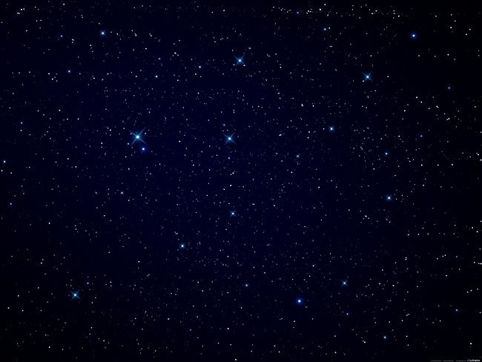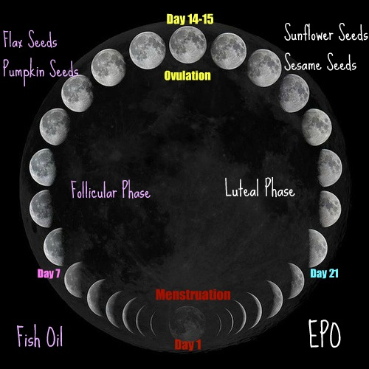

Seed Cycling

Balance Your Hormones Naturally

For extra support add:

**Day 1 – 14:**

Fish oil

**Day 15 – 28:**

Evening Primrose Oil (EPO)

**Instructions:**

Add seeds according to your cycle. Grind them and add to smoothies, yogurt, cereal, soups, salads or just about anything.

**Day 1 – 14:**

Grind 1 tbsp flax seeds and 1 tbsp pumpkin seeds and add those to your diet.

**Day 15 – 28:**

Grind 1 tbsp sunflower seeds and 1 tbsp sesame seeds and add those to your diet.

Women and Moonlight

In our natural “wild” state women’s cycles follow the moon. We ovulate and are fertile at the full moon (the brightest nights) and menstruate, or bleed, on the darkest nights. Eliminate as much artificial light as possible from your sleep environment and just have moonlight. If your neighbors have spotlights like mine do, then block all light from outside and use a small light for three days around the full moon to help trigger your body.

To Start Seed Cycling

If your cycle is close to regular but not quite there then start seed cycling on Day 1 of a new cycle.

If your cycle is nothing like regular or totally unpredictable, start seed cycling on the new moon and see if you can get in sync.